**Extending**

**SpotfireDemo App**

**Documentation**

**(Windows Forms)**

**(Cloud Databases)**

**(TIBCO Spotfire Visuals)**

**Table Of Contents**

1. **Introduction……………………………….………….. 2**
2. **Signup………………………………………......….…. 2**
3. **Setup Guide……………..……………………..……. 2 - 20**
   1. **Navigate To Console……………..……………………....…. 2 - 3**
   2. **Creating AWS Database Server………………..…...……. 4 - 5**
   3. **Creating AWS Database ……………..………………..…... 5 - 7**
   4. **Potential Bugs…………..………………..……………….... 7 - 14**
      1. **School WiFi Blockage……………………….…....... 7 - 8**
      2. **Other Potensi Bugs…………………………............ 9 - 14**
         1. **SQL Server Configuration Manager……. 9 - 10**
         2. **Using TCPView…………………………….. 11**
         3. **Using Windows Defender Firewall…….. 12 - 13**
         4. **Using Services…………………………….. 14**
4. **Connecting To WinForms……………………..…… 15 - 18**
   1. **Codes……………………………..……………….……...…. 16**
   2. **Copy Of Database Table……………………...…..………. 17 - 18**
5. **Connecting To Spotfire..……………………..……. 19**
6. **References……………………………………..……. 20 - 23**
   1. **General..………………………………………………….…. 20**
   2. **Window Forms C#…………………….…………..………. 20**
   3. **AWS RDS (Microsoft SQL Edition)...………………..…. 21 - 23**
   4. **Languages……………..……………………………… 23**
   5. **Additional C# Related…...…………………………… 23**

**1. Introduction**

This documentation report was requested to explain ONLY Amazon RDS. it will cover topics such as signing up, set up, and connect into TIBCO Spotfire and WinForms. It also cover troubleshooting and potential bugs when using AWS RDS.

Before continuing this documentation, please have a read on the “Extending SpotfireDemo App” Documentation as it may also help understand more about using Amazon RDS

**2. Signup**

Enter the AWS website [here](https://aws.amazon.com/) and create an AWS account. It will require you to provide your credit card information as well.

**3. Setup Guide**

**3.1 Navigate To Console**

After you have finished registration, proceed to log into your account and enter the Console for AWS. Inside the console, you may change your region to Singapore or leave it. It has no real effect.

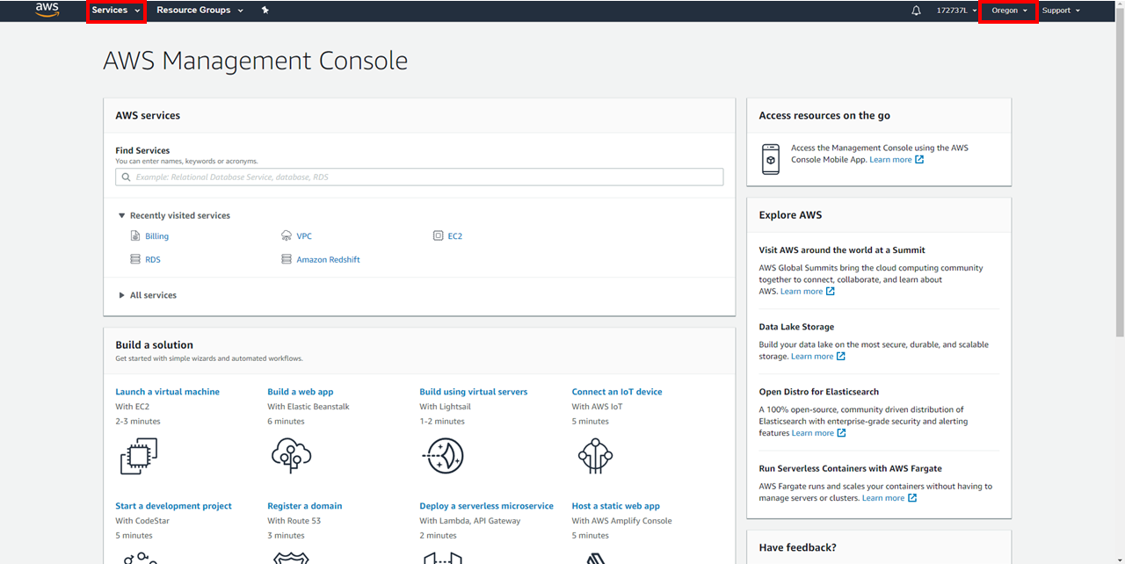

Then click on “Services > Database > RDS”. This will be the main AWS service we will be using as the AWS Cloud Database Server.

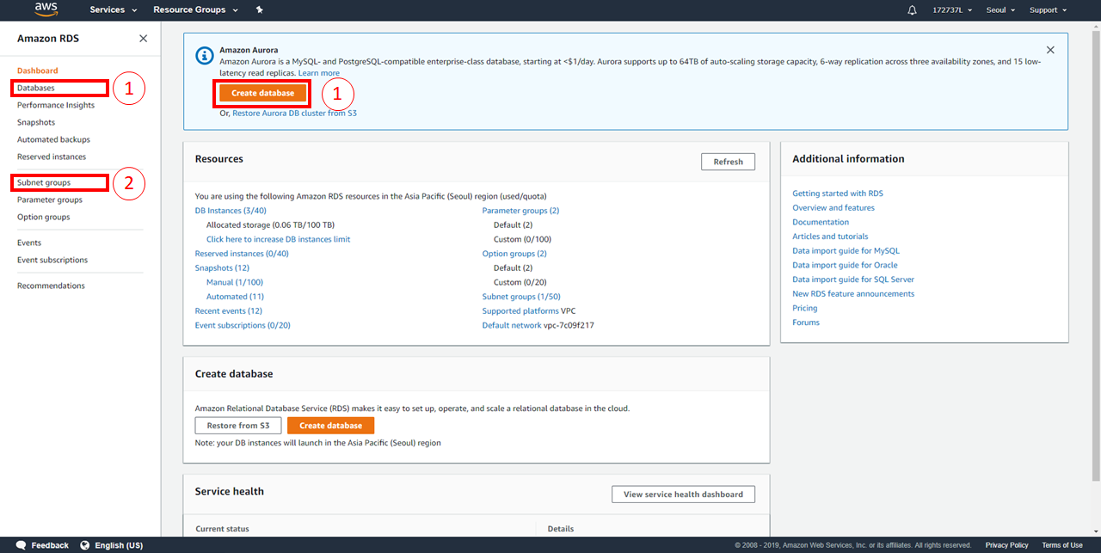

**In Section 1:**

You can create a database from either option.

**In Section 2:**

You can create a subnet group to store all subnets into a single group. This subnet group will be used for your database creation.

**3.2 Creating AWS Database Server**

As of writing this report, a new tutorial/method of creating a database is now available, labelled “Easy create”. You may follow the new method by using the official guide [here](https://docs.aws.amazon.com/AmazonRDS/latest/UserGuide/CHAP_GettingStarted.CreatingConnecting.SQLServer.html). I will be explaining how to create a Microsoft SQL Database Server with the old method.

Before clicking on “Create Database”, go to the “Subnet groups” tab and create a subnet group. This subnet group will be used for the database server creation. Creating the subnet group, follow the prompts accordingly.

1. Name: Your group name
2. Description: Your group description
3. VPC: Use default
4. Add subnets: Click on “Add all the subnets related to this VPC”

Then proceed to create your subnet. It will be displayed inside your lists of subnet groups.

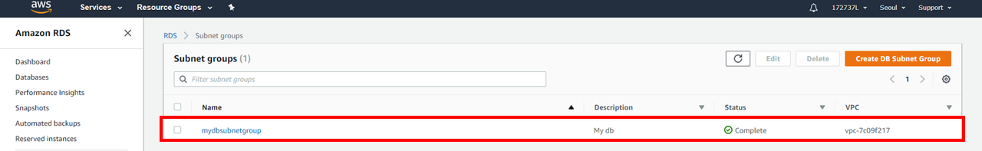

Now creating a database, uncheck “Easy create” and select the Engine Type “Microsoft SQL Server”. Next select the following options:

1. Edition: SQL Server Express Edition
2. Version: Any version
3. Templates: Free tier
4. DB Instance Identifier: Your DB server name
5. Master Username: Any name
6. Master Password: Any password
7. Under “Additional connectivity configuration”
   1. Subnet group: Use your new subnet group created
   2. Publicly Accessible: Yes
   3. VPC security group: Create new
8. Use the default settings for the rest of the options

Once the following options are filled, proceed to “Create Database”. The database will then be displayed inside the “Databases” tab as follows.

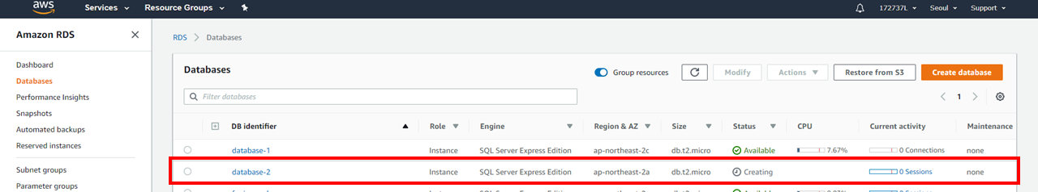

After the database is created, it may not be usable based on the blocked contents by the school WiFi. The school Wifi blocks all of the ports used for an AWS MSSQL Database Server. Hence, I will guide how to go around using the same school WiFi with a VPN to connect your AWS Database Server in the “2.2.2 School WiFi Blockage” section of this report.

**3.3 Creating AWS Database**

The next step after creating your AWS Database Server is to create an AWS Database. To create a database, you may follow this video [here](https://www.youtube.com/watch?v=EBTBCBUGR4I&fbclid=IwAR1xZIttetMUBJhBG1zO80DFIe3vjPGQhVArNpXdGrG3D2zvy54_13su1KY) at timestamp 7:40. I will still be sharing on how to create an AWS Database on my part of this report.

First, ensure that you have SQL Management Studio 2012 Installed. It can be downloaded [here](https://www.microsoft.com/en-sg/download/details.aspx?id=29062). The installation will come with the main SQL Management Studio 2012 and SQL Server Configuration Manager 2012.

Keep both software as Management Studio will be used to create the database, while Server Configuration Manager will be used for later debugging for any potential bugs.

After completing installation, open your Management Studio. On first startup, a popup will appear to prompt for an immediate SQL Server connection.

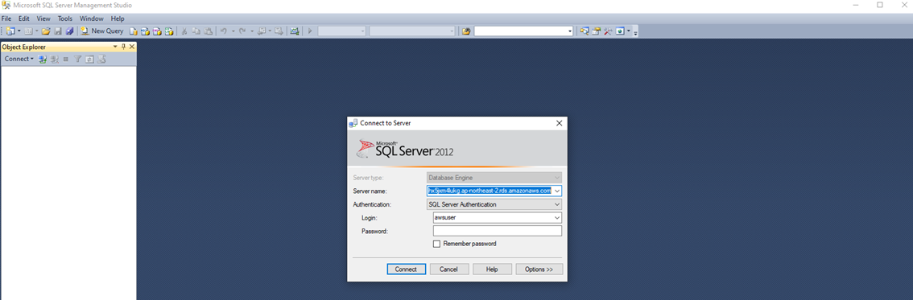

With your AWS RDS console website open, select your database server and copy the endpoint to the SQL Server connection prompt under “Server name”. If your port is other than 1443, the “Server name” must be “Endpoint, Port”.

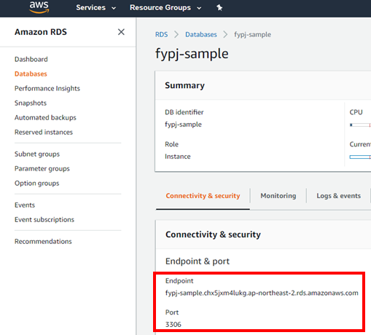

Select SQL authentication and enter your master username and password. Finally, create a connection.

**Note**: A connection may require a VPN using school WiFi.

Once a connection is created, your AWS connection will appear at the left of Management Studio.

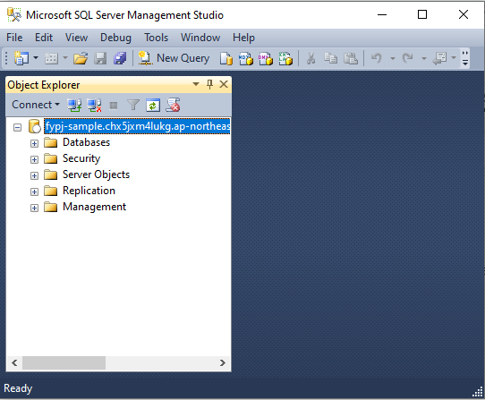

With the connection established, proceed to create a database. Right click the fold “Databases” and create a new database, then enter a database name and click “OK”.

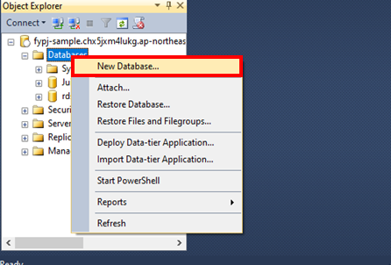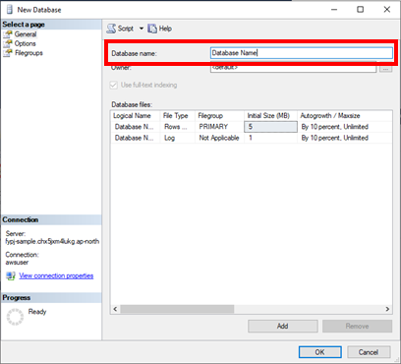

This will wrap up the creation of a database for your future Visual Studio project.

**3.4 Potential Bugs**

**3.4.1 School WiFi Blockage**

With the school WiFi, it has caused certain ports to be blocked and rendered unusable. These ports are important for our AWS RDS connection. As of writing this report, the following ports 5222, 5223, 5228 and 59234 is able to connect to the AWS database server. However, they may not be available in the future.

For a backup alternative, a solution was found with VPNs. Hence, I will be sharing how to use a VPN and also recommend a VPN provider to use for this project.

By using a VPN, we can mask the school WiFi to allow the access of the port 1433, the default port used for the AWS RDS database. The desired port used may be different based on how you configured your AWS Cloud Database Server.

For any VPN services, just enable the VPN then to create a connection in Visual Studio’s Server Explorer with your AWS RDS database. Ensure the the AWS RDS database is a MS SQL Database. Now, you are successfully connected to the database.

If you do not have any VPN, I recommend using WindScribe. With WindScribe, you will get free VPN data renewed monthly. It will start with only 4GB of data, but by verifying your Email, it will increase the limit to 10GB. You may also create multiple accounts to use as much data as you want. You can visit their website [here](https://windscribe.com/).

Installing the WindScribe software is required to enable their VPN. The software will appear as a small popup with a simple GUI.

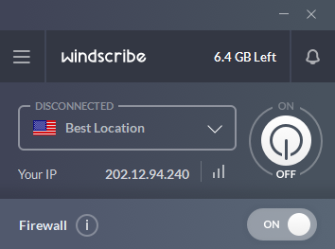

When using the VPN with the school WiFi, go to your “Preferences > Connection” and for “Firewall Mode” select “Manual”, then turn off the firewall. This is essential to unblock the AWS Port that we will be using.

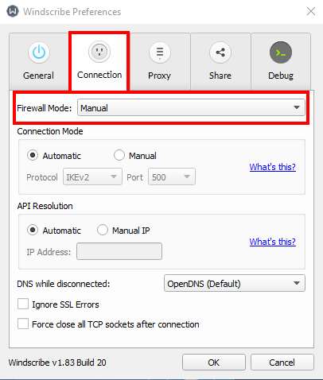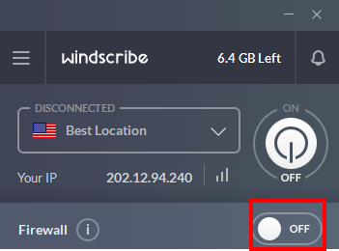

After configuration, just turn on the VPN whenever intending to open a connection to your AWS database server. Hence, I recommend WindScribe as it is user intuitive and easy to use.

**3.4.2 Other Potential Bugs**

In this section, I will be sharing my exploration findings on how to overcome potential bugs and an alternate solution to the blockage by school WiFi..

To fix the bugs, we will require numerous external software and prebuilt troubleshooting programs in Windows PC. We will be using the following lists of software and programs:  
  
Software:

1. SQL Server Configuration Manager
2. TCPView

Default Programs:

1. Windows Defender Firewall with Advanced Security
2. Services

**3.4.2.1 SQL Server Configuration Manager**

In this section of the Other Potential Bugs, we will be using SQL Server Configuration Manager to change a potential bug in the settings.

From previous installations, you would have already installed SQL Server Configuration Manager 2012 as it comes together with the SQL Server Management Studio.

To open your SQL Server Configuration Manager, at your windows search bar, type “Computer Management”. Then navigate to “Services and Applications > SQL Server Configuration”.

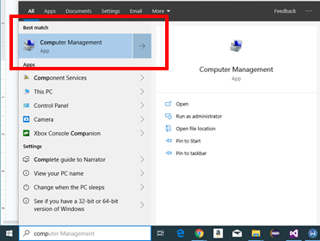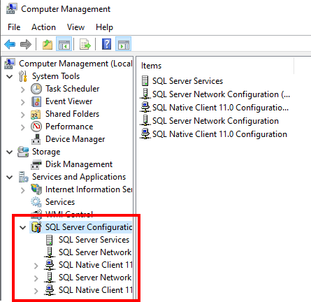

The following items inside “SQL Server Configuration” are the items we will be focusing. For every item labelled “Shared Memory”, “Named Pipes” and “TCP/IP”, change their status to “Enabled”.

Then, for “SQL Server Network Configuration > Protocols for SQLEXPRESS > TCP/IP”, open the properties and change the TCP Port to the same port that is currently used for the AWS connection,

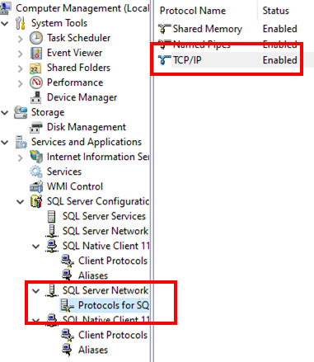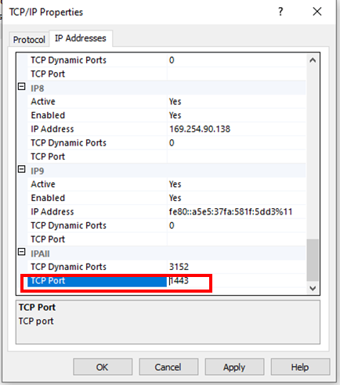

After changing every mentioned setting, navigate to “SQL Server Services > SQL Server (SQLEXPRESS)”. Then right-click and restart the “SQL Server (SQLEXPRESS).

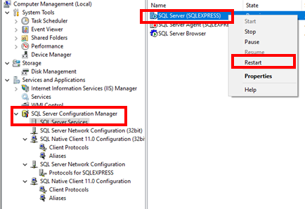

This will reboot with your new settings and hopefully be able to make a connection to your AWS database. If your connection still has problems, refer to the usage of other troubleshooting tools to identify the cause of the error.

**3.4.2.2 Using TCPView**

The TCPView tool is used to view all your ports that is being used. This tool is used to mainly help identify which endpoints are being used in both ends of the connection.

It does not directly troubleshoot any errors in connection; however, it helps understand and identify the cause of the error. The download can be found [here](https://docs.microsoft.com/en-us/sysinternals/downloads/tcpview?fbclid=IwAR1w-MGgOCf49Ddlkz-sguGKl_Y0Od_HWrMmduubqMjiTz6Uhq6n7rGIM-U) with documentation.

This is a sample of how the TCPView UI will look like:

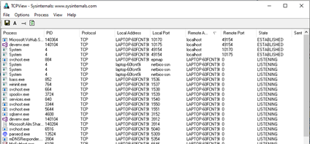

To allow for a readable address in digits, go to “Options > Resolve Addresses” and uncheck it. This will change the IP Address into digits.

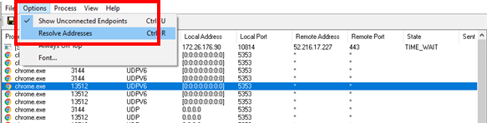

**3.4.2.3 Using Windows Defender Firewall**

The Windows Defender Firewall may have settings that block the connection to the AWS database. To fix this, I will be guiding how to configure the settings of the firewall.

At your search bar, type “Windows Defender Firewall”, then a popup will appear. In the popup, click on “Advanced settings”. This will open the final popup which is the main page to configure the firewall settings.

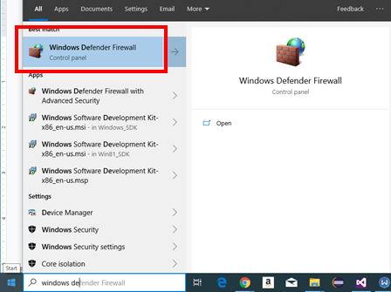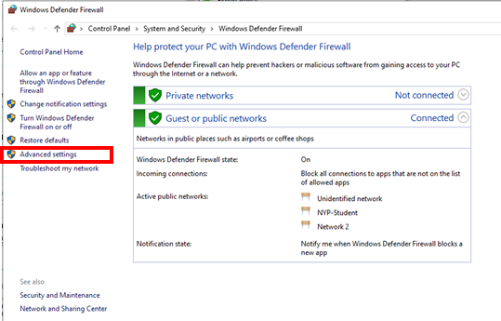

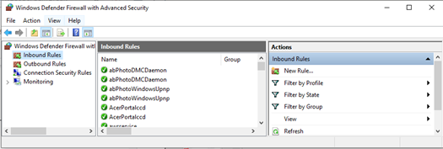

In this page, inside “Inbound Rules”, create a “New Rule”.

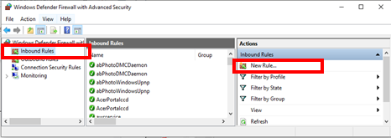

This will undergo creating a firewall rule to enable the connection to the AWS servers. In the first section, select “Port”. Then, select “TCP” and enter the desired port to be targeted. Next, select “Allow the connection” to ensure that the connection can be allowed.

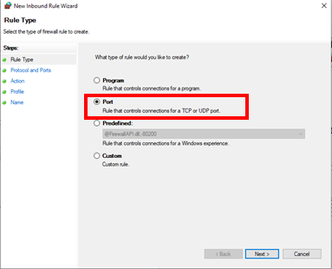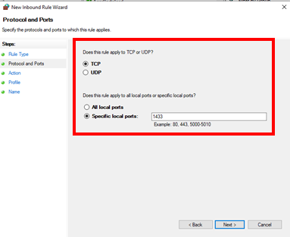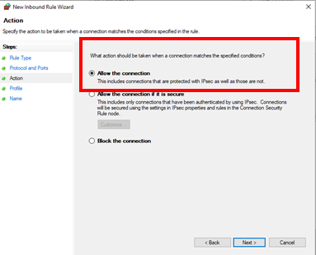

Then, check every checkbox, “Domain”, “Private”, “Public”. And finally, give your new rule a name and a short description.

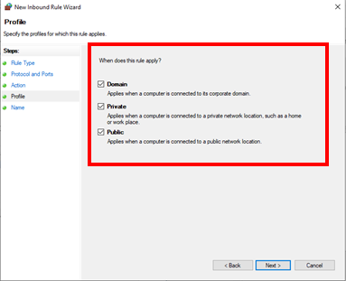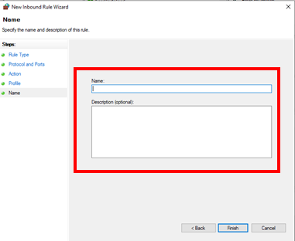

This will allow your firewall to ignore the port and allow that port to be used to create the AWS connection.

**3.4.2.4 Using Services**

Open your services by the windows search bar. A popup will open. In this popup, search for “SQL Server (SQLEXPRESS)” and “SQL Server Browser”. Ensure that both of these instances are “Running” status.

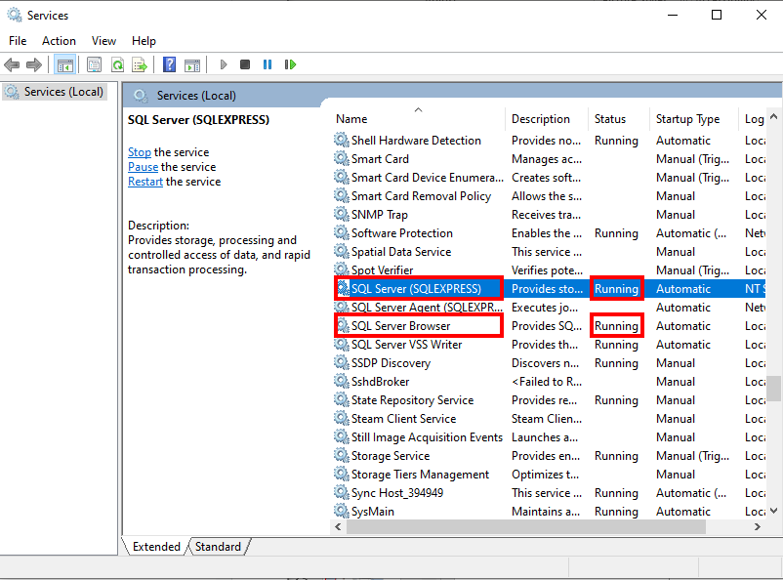

This is to ensure that your SQL Server connections are enabled to allow for connections to AWS databases.

**4. Connecting To WinForms**

Similar to the Google BigQuery explanation, the demo was made to utilize AWS RDS as a cloud database source. The demo is also accessible via running the Spotfire Demo App, and selecting the “Juice Sales (AWS RDS) tab.

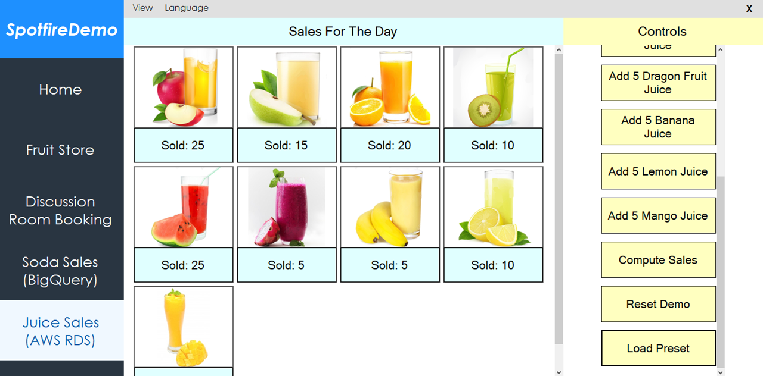

As previously mentioned in setup, you are required to use SQL Management Studio to first create a new database. Then you may view and edit the data via Visual Studio through the server explorer. And depending on the WiFi restriction, a VPN is required.

**4.1 Codes**

By opening the source codes of the project file “SpotfireDemo.cs” and “aws.cs”, you can see the codes to connect to the cloud database and to call/update the cloud database, respectively.

The given database connection string has already expired and will not be usable.

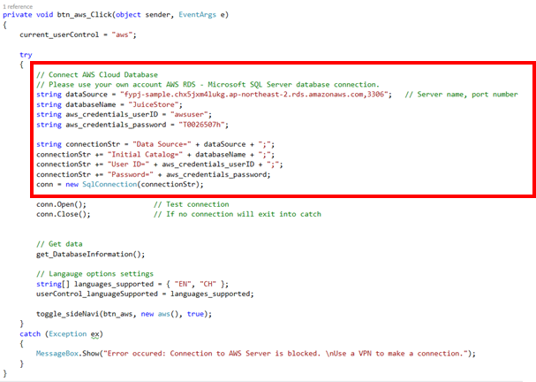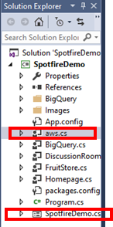

The demo codes for this portion is also very lengthy and complicated, hence, best to explore the source codes by yourself as well. Comments is also provided inside the source codes.

**Note**: When providing your own connection string, use the template in the image above. But use your own database connection.

**4.2 Copy Of Database Table**

Using your Visual Studio, copy the following database table schema and the data.

**Database Schema:**

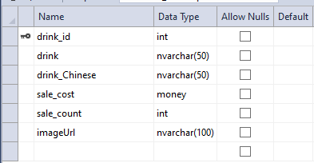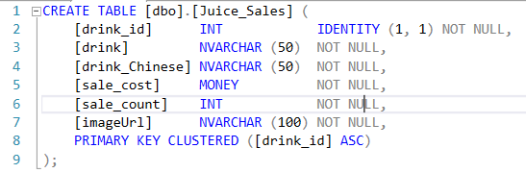

CREATE TABLE [dbo].[Juice_Sales] (

[drink_id] INT IDENTITY (1, 1) NOT NULL,

[drink] NVARCHAR (50) NOT NULL,

[drink_Chinese] NVARCHAR (50) NOT NULL,

[sale_cost] MONEY NOT NULL,

[sale_count] INT NOT NULL,

[imageUrl] NVARCHAR (100) NOT NULL,

PRIMARY KEY CLUSTERED ([drink_id] ASC)

);

**Database Data:**

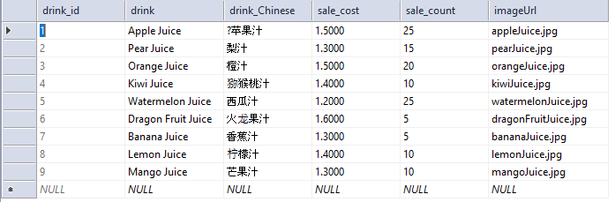

|  |  |  |  |  |  |
| --- | --- | --- | --- | --- | --- |
| 1 | Apple Juice | ?苹果汁 | 1.5000 | 25 | appleJuice.jpg |
| 2 | Pear Juice | 梨汁 | 1.3000 | 15 | pearJuice.jpg |
| 3 | Orange Juice | 橙汁 | 1.5000 | 20 | orangeJuice.jpg |
| 4 | Kiwi Juice | 猕猴桃汁 | 1.4000 | 10 | kiwiJuice.jpg |
| 5 | Watermelon Juice | 西瓜汁 | 1.2000 | 25 | watermelonJuice.jpg |
| 6 | Dragon Fruit Juice | 火龙果汁 | 1.6000 | 5 | dragonFruitJuice.jpg |
| 7 | Banana Juice | 香蕉汁 | 1.3000 | 5 | bananaJuice.jpg |
| 8 | Lemon Juice | 柠檬汁 | 1.4000 | 10 | lemonJuice.jpg |
| 9 | Mango Juice | 芒果汁 | 1.3000 | 10 | mangoJuice.jpg |

Once your database table is completed, using the demo app, you can control the with the buttons at the side of the page. The buttons are the main tools used to test the demo app to utilize the usage of AWS RDS database servers.

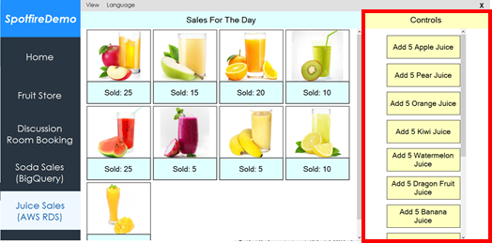

**Note**: The data changed can only be shown using an external software like Visual Studio. And to create a new table, you must use SQL Management Studio.

**5. Connecting To Spotfire**

The final step is to link to Spotfire and create visualisations with this demo. First, open your TIBCO Spotfire. Then, create a connection to Microsoft SQL Servers. This is because the database server type of your AWS RDS is MS SQL.

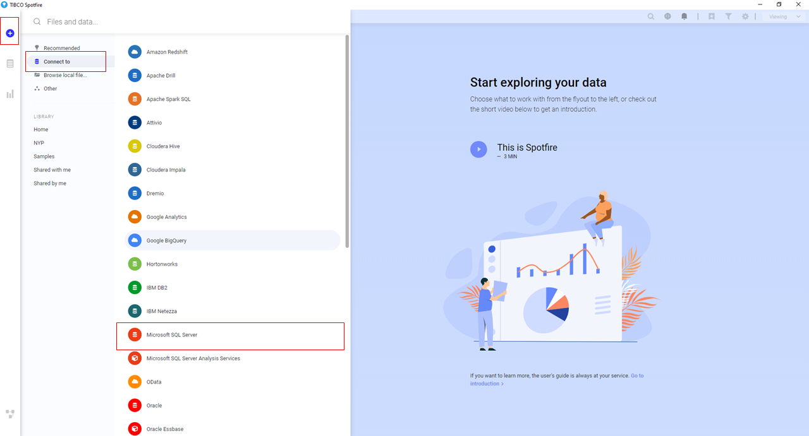

Once done, play around with your newly created Analysis and create a visualisation set.

An example of my visualisation set is shown below.

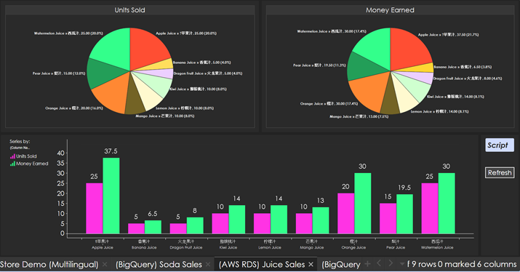

**6. References**

**6.1 General**

AWS Amazon:

<https://aws.amazon.com/>

Microsoft SQL Server 2012 Express Download:

<https://www.microsoft.com/en-sg/download/details.aspx?id=29062>

**6.2 Window Forms C#**

Duplicate WinForms form: <https://stackoverflow.com/questions/1268591/how-to-easily-duplicate-a-windows-form-in-visual-studio>

Programmatic Button Click:

<https://stackoverflow.com/questions/16792160/how-to-trigger-a-button-click-in-my-code>

C# ArrayList:

<https://www.geeksforgeeks.org/c-sharp-arraylist-class/>

<https://www.tutorialspoint.com/csharp/csharp_arrays>

ArrayList Check Value Exist:

<https://stackoverflow.com/questions/7867377/checking-if-a-string-array-contains-a-value-and-if-so-getting-its-position>

Array IsNullOrEmpty:

<https://stackoverflow.com/questions/8560106/isnullorempty-equivalent-for-array-c-sharp>

Foreach Loop:

<https://docs.microsoft.com/en-us/dotnet/csharp/language-reference/keywords/foreach-in>

Round 2 Decimal:

<https://stackoverflow.com/questions/164926/how-do-i-round-a-decimal-value-to-2-decimal-places-for-output-on-a-page>

Convert String To Float:

<https://stackoverflow.com/questions/11202673/converting-string-to-float-in-c-sharp>

InnerException property of TypeInitializationException:

<https://stackoverflow.com/questions/4398334/the-type-initializer-for-myclass-threw-an-exception>

Get Number Of Rows With SqlDataReader:

<https://stackoverflow.com/questions/1383315/how-to-get-number-of-rows-using-sqldatareader-in-c-sharp>

**6.3 AWS RDS (Microsoft SQL Edition)**

**6.3.1 Official Notes**

Pricing:

<https://aws.amazon.com/rds/sqlserver/pricing/>

**6.3.2 Database SQL Queries**

Sql Null Functions:

<https://www.w3schools.com/sql/sql_isnull.asp>

Sql Where Clause:

<https://www.w3schools.com/sql/sql_where.asp>

Sql Aliases:

<https://www.w3schools.com/sql/sql_alias.asp>

Sql Count(), Avg(), Sum() Functions:

<https://www.w3schools.com/sql/sql_count_avg_sum.asp>

Adding Parameters to Commands:

<https://csharp-station.com/Tutorial/AdoDotNet/Lesson06>

**6.3.3 Setup Help**

Setting Up for Amazon RDS:

<https://docs.aws.amazon.com/AmazonRDS/latest/UserGuide/CHAP_SettingUp.html#CHAP_SettingUp.SecurityGroup>

Amazon Virtual Private Cloud VPCs and Amazon RDS:

<https://docs.aws.amazon.com/AmazonRDS/latest/UserGuide/USER_VPC.WorkingWithRDSInstanceinaVPC.html#USER_VPC.CreatingVPC>

**6.3.4 Additional Setup Help**

AWS Connection With C# tutorial:

<https://www.youtube.com/watch?v=EBTBCBUGR4I&fbclid=IwAR1xZIttetMUBJhBG1zO80DFIe3vjPGQhVArNpXdGrG3D2zvy54_13su1KY>

How to install SQL Server Management Studio 2012:

<https://www.hivelocity.net/kb/how-to-install-sql-server-management-studio-2012-on-windows-server-2012/>

SQL Server Database connection error on Amazon RDS:

<https://saaction.blogspot.com/2017/05/sql-server-database-connection-error-on.html?fbclid=IwAR2kA3IPkaBQXYri7Wtv8CUvZT1JNsBQrmdeiu-Bv4K9wU_dEN7tmZX09Ps>

Cannot connect to my RDS database:

<https://forums.aws.amazon.com/thread.jspa?threadID=115067>

Connect to SQL Server Error:

<https://www.experts-exchange.com/questions/28746979/Connect-to-SQL-Server-Error.html?fbclid=IwAR3DTBRdnStikbw-VVCExGYucivBtdFGzVZaeCLRVBehHC0rfph3MjDGrlw>

Fix SQL Server Error 53: Could not open connection on SQL Server:

<https://techyaz.com/sql-server/troubleshooting/fix-error-53-not-open-connection-sql-server/>

“A network- related or instance-specific error occurred”: <https://www.lansweeper.com/knowledgebase/a-network-related-or-instance-specific-error-occurred/>

How to fix error ‘Named Pipes Provider, error 40 - Could not open a connection to SQL Server’:

<https://stackoverflow.com/questions/9945409/how-do-i-fix-the-error-named-pipes-provider-error-40-could-not-open-a-connec?fbclid=IwAR2CVje64W609EYfBLfbIFbAwXCzzZzlJ0whAVmn8dpStcoettt8YRnjf14>

How to fix SQL connection in SQL Server Management Studio 2017:

<https://www.youtube.com/watch?v=9O4-2QjoEVo>

MSSQLSERVER service on Local Computer, started then stopped:

<https://stackoverflow.com/questions/35080354/the-mssqlserver-service-on-local-computer-started-and-then-stopped-some-service>

**6.3.5 Potential Bugs Solutions**

How to open ports on the Windows Firewall:

<https://serverfault.com/questions/221075/how-to-know-currently-open-ports-on-the-windows-firewall>

TCPView Download And Guide:

<https://docs.microsoft.com/en-us/sysinternals/downloads/tcpview?fbclid=IwAR3ZkBndUp837A5juzWaect4FeWRA4oCCtPEK4COzgEa3CbOJ4Hed5PMH64>

SQL Server TCP and UDP Ports:

<https://www.itprotoday.com/sql-server/sql-server-tcp-and-udp-ports?fbclid=IwAR0EyxoOjOFFyGJFmtNKYw93nlHmuHaHY-nCxFly6L9OrDviVMkITdrLN5s>

Overview of common TCP and UDP default ports:

<https://www.examcollection.com/certification-training/network-plus-overview-of-common-tcp-and-udp-default-ports.html?fbclid=IwAR2nAMZXxjqPke-gN_9XNyoTev1YVn71du-QVgbTyFbjjbLh34HHOjGGqr8>

How to specify a Port Number to Connect to SQL Server Instance:

<http://zarez.net/?p=3305>

Guide To Change AWS Port:

<https://www.cloudconformity.com/conformity-rules/RDS/rds-default-port.html>

**6.3.6 Others**

**6.3.6.1 VPN Solution**

WindScribe:

<https://windscribe.com/>

**6.3.6.2 SQL Server Configuration Manager Guide**

SQL Server Configuration Manager:

<http://lexisnexis.custhelp.com/app/answers/answer_view/a_id/1095989/~/sql-server-configuration-manager-general-information>

**6.3.6.3 TPCView Guide**

TPCView:

<https://docs.microsoft.com/en-us/sysinternals/downloads/tcpview?fbclid=IwAR1w-MGgOCf49Ddlkz-sguGKl_Y0Od_HWrMmduubqMjiTz6Uhq6n7rGIM-U>

**6.4 Language**

Drinks in Chinese:

<https://blogs.transparent.com/chinese/chinese-vocabulary-drinks/>

<https://www.fluentu.com/blog/chinese/2013/03/08/essential-chinese-vocabulary-word-list-drinks/>

<https://blogs.transparent.com/chinese/get-your-drink-on/>

**6.5 Additional C# Related**

Array Reverse Method:

<https://docs.microsoft.com/en-us/dotnet/api/system.array.reverse?view=netframework-4.8>

ListBox Word Wrap alternative:

<https://social.msdn.microsoft.com/Forums/vstudio/en-US/9b69fcd9-e9af-4f06-96e9-f164ee6e5428/list-box-word-wrap?forum=vbgeneral>

String.Replace() Method:

<https://www.geeksforgeeks.org/c-sharp-replace-method/>

Foreach Loop, Find Last Iteration:

<https://stackoverflow.com/questions/7476174/foreach-loop-determine-which-is-the-last-iteration-of-the-loop>

Parse Strings Using String.Split:

<https://docs.microsoft.com/en-us/dotnet/csharp/how-to/parse-strings-using-split>

Convert Double To Nearest Integer:

<https://stackoverflow.com/questions/633335/how-might-i-convert-a-double-to-the-nearest-integer-value/633340>

Generate Random Int Number:

<https://stackoverflow.com/questions/2706500/how-do-i-generate-a-random-int-number>

Generate Random Alphanumeric String:

<https://stackoverflow.com/questions/1344221/how-can-i-generate-random-alphanumeric-strings>